We are seeking your support to nominate outstanding women immunologist
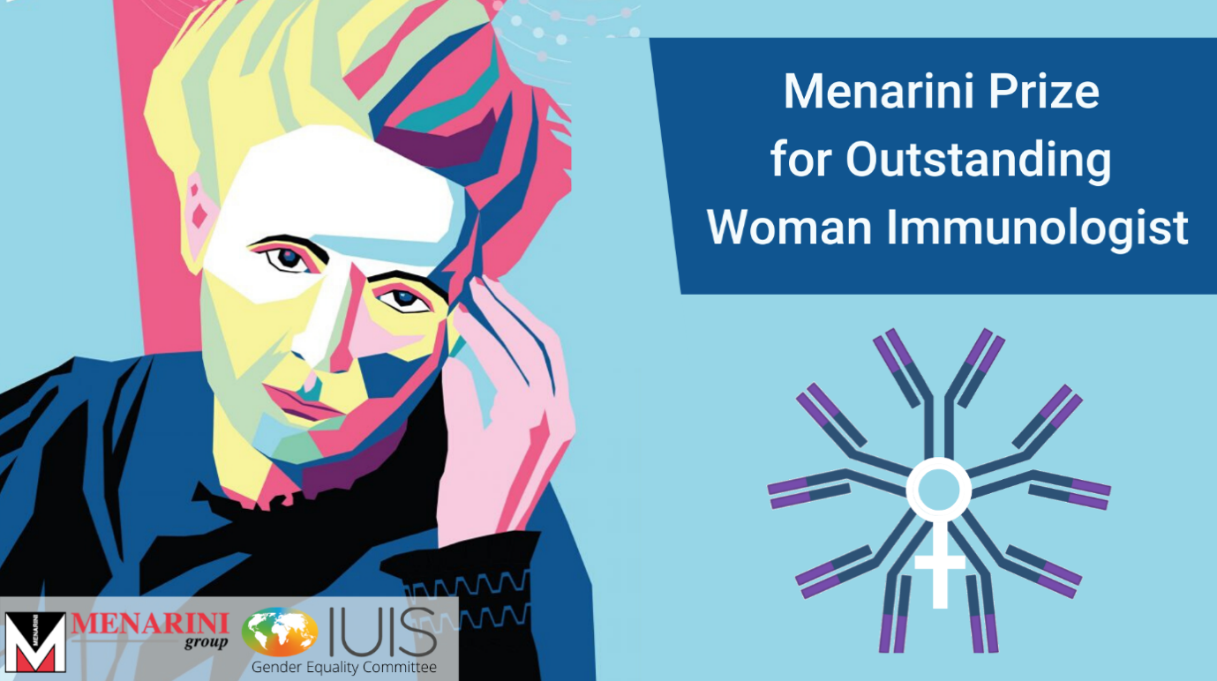
On the occasion of the Day of Immunology on April 29th, IUIS and its Gender Equality Committee (GEC) proudly announced the “Menarini Prize for Outstanding Woman Immunologist” established thanks to the forward-looking vision and generous support of the Menarini Group.
The USD 40,000 prize will be awarded for the first time at the 18th International Congress of Immunology (IUIS 2023) in Cape Town, South Africa in 2023 and at future IUIS congresses thereafter. This award is the first and only IUIS prize that specifically recognizes women immunologists and their outstanding research accomplishments. Rules for nominations and selection of awardees will be announced at a later stage.
Rules for Nomination and Selection of Winners
A Nomination Committee (NC) composed of 101 outstanding immunologists has been formed. The IUIS commitment to equality and diversity across the divides of race, age, national origin or social status is reflected to the extent possible in the composition of the NC. Each member of the NC is responsible for collecting one nomination consisting of the following:
- CV of the nominee
- List of her publications and/or other research achievements
- A letter of motivations from the candidate
- A letter of support from the NC member
Female members of the NC may self-nominate, in which case they must submit two letters of support for their nomination from two other members of the Nomination Committee.
A Selection Committee (SC) composed of 12 outstanding immunologists, including Past Chair of the GEC Committee, is formed for a three-year term (current term is 2020-2022). Members of the SC are collectively responsible for selecting three candidates from the nominations received. The GEC Committee and the IUIS President will identify the winner from the shortlist.
The list of the Nomination Committee members of the Menarini Prize for Outstanding Woman Immunologist is published on the IUIS website/ GEC Committee
We are seeking your support to advertise this Award within your Society of Immunology

